

Republic of the Philippines
PALAWAN STATE UNIVERSITY
College of Science
Puerto Princesa City

SCHOOL ATTEDANCE MANAGEMENT SYSTEM
A Web Application/Documentation project in our course subject
Application Development and Emerging Technologies

In Partial Fulfillment of the requirements for the degree of
Bachelor of Science in Computer Science

Presented by:
Alili, Philip Arland
Cayabyab, Charls Brent

June 2023

TABLE OF CONTENTS
TITTLE……………………………………………………………………………………… 1
TABLE OF CONTENTS …………………………………………………………………. 2
CHAPTER I
INTRODUCTION……………………………………………………………………………3
CHAPTER II
METHODOLODY
2.1 Requirement Gathering………………………………………………………………5
2.2 System Design…………………………………………………………………………5
2.3 Development……………………………………………………………………………6
2.4 Development and Training ……………………………………………………………7
2.5 Infrastructure Requirements………………………………………………………….7
CHAPTER III
RESULTS AND DISCUSSION
3.1 School Registration…………………………………………………………………8
3.2 Attendance Tracking………………………………………………………………9
3.3 Report Analysis…………………………………………………………………….9
3.4 Notifications and Alerts……………………………………………………………10
DISCUSSION
3.5 Improved Efficiency………………………………………………………………….10
3.6 Enhanced Communication…………………………………………………………11
3.7 Accurate Data Reporting……………………………………………………………11
3.8 Data Security and Privacy ………………………………………………………….12
CONCLUSION……………………………………………………………………13 - 16

CHAPTER I
INTRODUCTION
In the digital age, technology has permeated almost every aspect of our lives, transforming the way we work, communicate, and even learn. One area that has witnessed significant advancements is the education sector, where innovative solutions are being developed to enhance efficiency, streamline processes, and improve student outcomes.
Among these groundbreaking developments, the School Management Attendance System stands as a revolutionary tool that aims to revolutionize the way attendance is managed in educational institutions. This system leverages cutting-edge technology to automate and simplify the attendance tracking process, ensuring accurate records, reducing administrative burden, and fostering a more productive learning environment.
This article delves into the intricacies of the School Management Attendance System, exploring its components, benefits, implementation strategies, and potential challenges.
The School Attendance Management System is a web-based application designed to automate and streamline the process of tracking and managing student attendance in schools. This system aims to replace manual attendance recording methods, such as paper-based registers, with a more efficient and accurate digital solution.
The importance of accurate attendance records in schools cannot be overstated. Attendance data is crucial for monitoring student attendance patterns, identifying trends, and ensuring compliance with school policies and regulations.
The School Attendance Management System aims to improve attendance management by providing a centralized platform that simplifies the attendance tracking process and enhances communication between teachers, students, and parents, the system empowers teachers and administrators to make informed decisions, identify attendance patterns, and intervene promptly when necessary. Embracing the School Attendance Management System allows educational institutions to optimize resources, enhance student engagement, and create a more productive learning environment that sets the stage for success in the digital age.

CHAPTER II
METHODOLOGY

2.1 Requirement Gathering
During this step, feedback and requirements are collected from various stakeholders, including teachers, administrators and Students. This is typically done through interviews, surveys, or focus groups. The goal is to understand the specific needs and expectations from the attendance management system. Important considerations include the desired features and functionalities, user interface preferences, data requirements, and any specific challenges or constraints.

2.2 System Design
Based on the gathered requirements, the system design phase begins. This involves specifying the user interface, functionality, and data structures of the School Attendance Management System. Designers determine the data fields required for attendance tracking, such as student details, class schedules, and attendance records. User roles and permissions are defined to ensure appropriate access levels. Additionally, the user interface is designed to be intuitive and user-friendly, considering the needs of teachers, administrators, and other users.

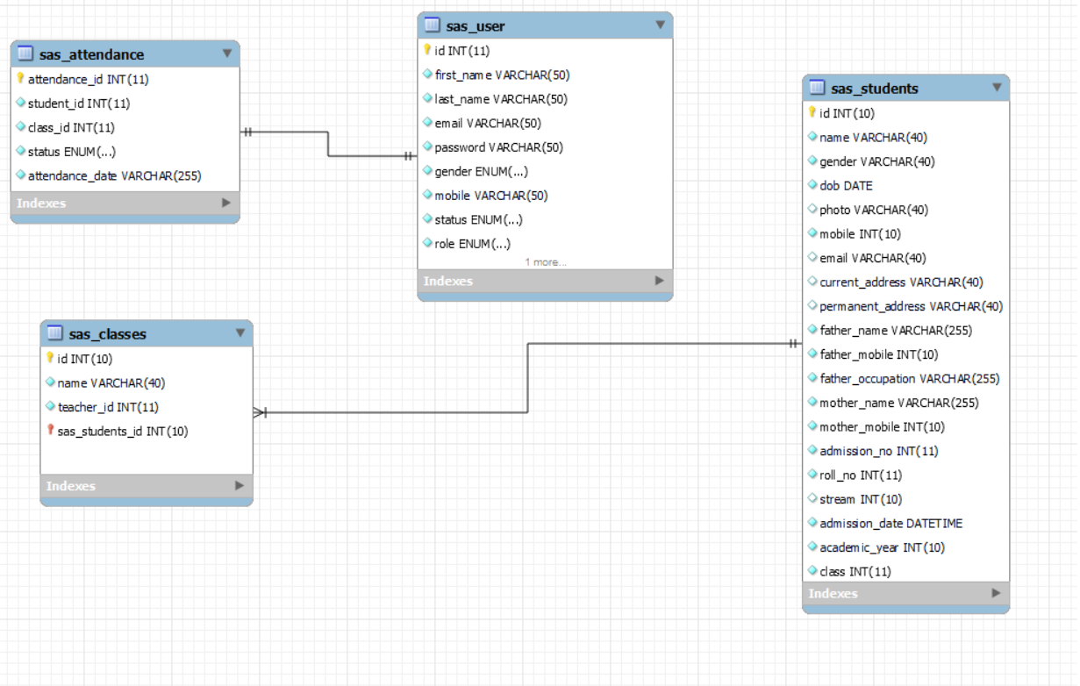
2.3 Development
Once the system design is finalized, the development phase begins. Appropriate technologies and programming languages are chosen based on the project requirements, such as PHP and SQL, may be utilized to create a responsive and interactive user interface. Database management systems, such as MySQL are selected to store and manage attendance data securely. Developers write the necessary code, create database schemas, and integrate the various components of the system.

2.4 Deployment and Training:
Once the system has been thoroughly tested and refined, it is ready for deployment in the school environment. The system is installed on servers or cloud platforms, ensuring it is accessible to the intended users. Teachers, administrators, and relevant staff members receive comprehensive training on how to effectively use the School Attendance Management System. This training may include hands-on sessions, user manuals, or video tutorials. Ongoing technical support and assistance are provided to ensure a smooth transition to the new system.

Overall, this systematic methodology ensures that the School Attendance Management System is developed based on the specific needs of the stakeholders, thoroughly tested for functionality and usability, and effectively deployed and supported in the school environment. The iterative nature of the process allows for continuous improvement and adaptation to evolving requirements.

2.5 Infrastructure Requirements
Implementing the School Management Attendance System requires a robust technological infrastructure, including network connectivity, biometric devices or smart card readers, and servers for data storage. Educational institutions need to assess their existing infrastructure and make necessary upgrades or investments to ensure smooth implementation.

CHAPTER III
RESULTS AND DISCUSSION

3.1 Student Registration:
The School Attendance Management System allows teachers or administrators to register students within the system. They can input important student details such as names, classes, and contact information. This registration process ensures that accurate student information is stored in the system and serves as a basis for attendance tracking.
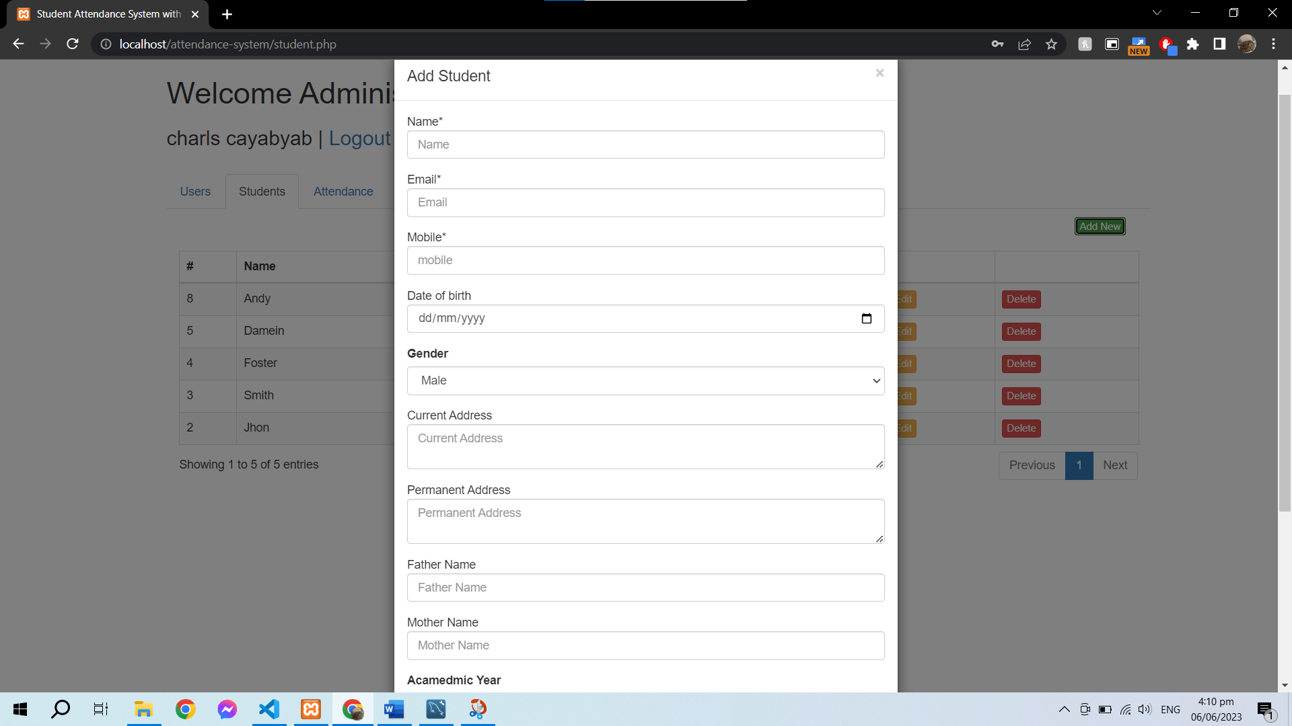

3.2 Attendance Tracking
The system provides an intuitive interface for teachers to record student attendance. They can mark attendance manually by selecting the presence or absence status for each student.
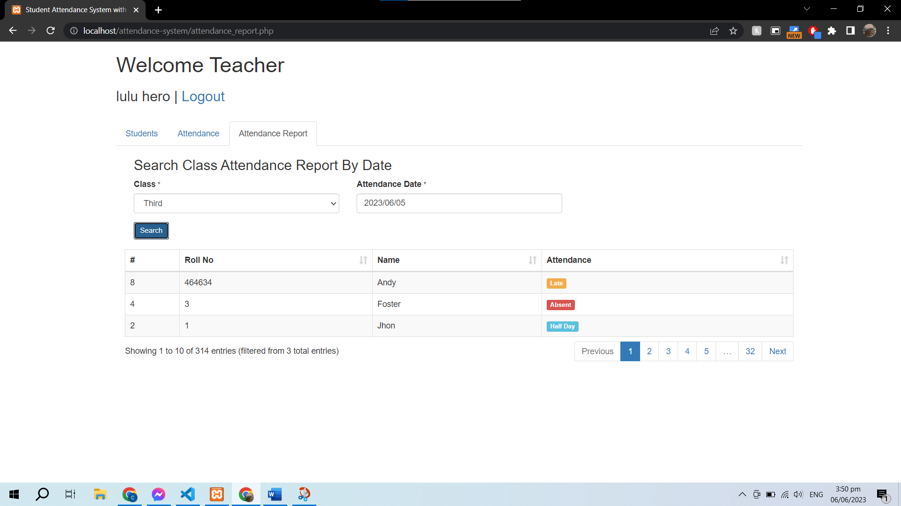

3.3 Reporting and Analysis:
One of the key functionalities of the School Attendance Management System is generating comprehensive attendance reports. Teachers and administrators can access these reports to monitor attendance patterns for individual students, specific classes, or specific time periods. The reports provide insights into attendance trends, allowing educators to identify students with high absenteeism or punctuality issues. This data can inform interventions and support strategies to improve attendance rates.

3.4 Notifications and Alerts:
The system includes a notification and alert feature that automatically sends updates to teachers, parents, and administrators regarding attendance-related matters. For example, if a student is absent or arrives late, the system can send an automated notification to the relevant stakeholders. These notifications help keep everyone informed about attendance updates in real-time, allowing for timely action and communication between teachers, parents, and school administrators.

DISCUSSION
3.5 Improved Efficiency:
Replacing manual attendance recording methods, the School Attendance Management System significantly improves efficiency. Teachers no longer have to spend time taking attendance manually and dealing with paper-based registers. The digital system streamlines the process by providing an intuitive interface for recording, managing, and analyzing attendance data. This saves teachers' time, allowing them to focus on other important tasks in the classroom.

3.6 Enhanced Communication:
The School Attendance Management System facilitates better communication among teachers, students, and parents. The system sends instant notifications and alerts to parents regarding their child's attendance status. This helps parents stay informed about their child's attendance and enables them to take necessary actions if there are any concerns. Improved communication between home and school promotes collaboration and ensures that parents are actively engaged in monitoring their child's attendance.

3.7 Accurate Data and Reporting:
Automated attendance tracking in the School Attendance Management System ensures accurate and reliable data. Teachers can rely on the system to capture attendance information accurately, eliminating errors that may occur with manual methods. The system generates comprehensive attendance reports that provide valuable insights into attendance patterns. Teachers and administrators can analyze these reports to identify trends, such as high absenteeism or punctuality issues, and take appropriate actions to address them. Data-driven decision-making becomes easier with access to reliable attendance information.

3.8 Data Security and Privacy:
The Developers make sure that the School Attendance Management System prioritizes data security and privacy. Robust security measures are implemented to protect student data from unauthorized access or breaches. Access controls are in place to ensure that only authorized personnel can access attendance records. Data encryption and secure authentication mechanisms provide an additional layer of protection for sensitive information. (Republic Act No. 10173) also known as the Data Privacy Act of 2012 (DPA), aims to protect personal data in information and communications systems both in the government and the private sector.

CONCLUSION
In conclusion, the School Attendance Management System offers an effective solution for managing student attendance in schools. Through automation and improved communication, it streamlines administrative tasks and promotes data-driven decision-making.
The system brings several benefits, including time savings, increased accuracy in attendance tracking, and enhanced collaboration among stakeholders. By facilitating better attendance management, the system contributes to improved student outcomes and overall school performance. Implementing the School Attendance Management System can lead to more efficient and effective attendance management practices in educational institutions. Moreover, the School Management Attendance System offers a comprehensive solution to the persistent challenges faced by educational institutions in managing attendance. The system's ability to accurately track and record attendance data eliminates the possibility of human errors and ensures reliable information for various stakeholders. This data can be used to analyze attendance patterns, identify trends, and make informed decisions to improve student attendance and engagement.

One of the significant advantages of the School Management Attendance System is its real-time monitoring capabilities. Teachers and administrators can access attendance information instantly, enabling them to address any attendance issues promptly. By identifying and addressing absenteeism or tardiness in real-time, educators can take proactive measures to support students who may be facing challenges or falling behind. This not only helps in improving student performance but also contributes to creating a positive and inclusive learning environment.

Another key aspect of the School Management Attendance System is its seamless integration with other modules and systems within the educational institution. The system can be easily integrated with existing student information systems, gradebooks, and scheduling tools, eliminating the need for duplicate data entry and ensuring consistency across different platforms. This integration facilitates a holistic view of student performance, allowing educators to make data-driven decisions regarding interventions, academic planning, and resource allocation.

Resource optimization is another significant benefit offered by the School Management Attendance System. Accurate attendance data enables educational institutions to allocate resources efficiently. For example, based on attendance patterns, schools can optimize staff deployment, classroom utilization, and other facilities. This ensures that resources are utilized optimally, reducing costs and improving overall operational efficiency.

The implementation of the School Management Attendance System requires careful consideration of the infrastructure requirements. Educational institutions need to assess their existing technology infrastructure and invest in the necessary hardware, software, and network connectivity to support the system. Adequate training and support for teachers, administrators, and other stakeholders are also crucial to ensure successful implementation. Training programs should focus not only on the technical aspects of using the system but also on understanding the system's benefits and how it can be effectively utilized to enhance the educational experience.

While the School Management Attendance System offers numerous advantages, it is essential to address potential challenges associated with its implementation. Privacy and security concerns are of paramount importance when dealing with personal data and biometric information. Educational institutions must establish robust security measures, adhere to data protection regulations, and clearly communicate policies regarding data handling and access to maintain the trust and confidence of students, parents, and staff.

Resistance to change can also pose a challenge during the implementation process. It is natural for stakeholders to be apprehensive about adopting a new system, particularly if they are accustomed to traditional attendance tracking methods. To mitigate resistance, clear communication and stakeholder engagement are crucial. Highlighting the benefits of the School Management Attendance System, providing training and support, and addressing concerns and misconceptions can help in gaining acceptance and ensuring a smooth transition.
In conclusion, the School Management Attendance System is a transformative tool that streamlines attendance management in educational institutions. By leveraging technology, this system brings accuracy, efficiency, and real-time monitoring to the process of tracking and recording attendance. The integration with other systems enables a comprehensive view of student performance, while resource optimization ensures efficient allocation of resources. While challenges may arise during implementation, addressing them through careful planning, training, and stakeholder engagement can lead to successful adoption. By embracing the School Management Attendance System, educational institutions can improve attendance tracking, foster a positive learning environment, and make data-informed decisions that ultimately contribute to student success.

